HRRAMS
Human Rights Reporting & Awareness Management System
System Design & Authentication
Architecture · Entity Relationship Model · Wireframes · Authentication
# | Deliverable | Covered in
i | System Architecture Diagram | Section 1
ii | Entity Relationship Diagram | Section 2
iii | Wireframes — five screens | Section 3
iv | Authentication System | Section 4
Prepared 2026-08-19

Contents

HRRAMS — Human Rights Reporting & Awareness Management System
This document covers the four deliverables of the System Design & Authentication phase:
# | Deliverable | Section
i | System Architecture Diagram | 1
ii | Entity Relationship Diagram | 2
iii | Wireframes (5 screens) | 3
iv | Authentication System | 4

Everything described here is implemented and has been exercised against a live MySQL database. Section 5 lists what was tested and the result. Section 6 states, honestly, what is not yet built.

1. System Architecture Diagram

1.1 Actor interaction
Who does what, and which part of the system answers them. Anonymous reporting is a first-class path: a citizen never has to hold an account to raise a complaint.
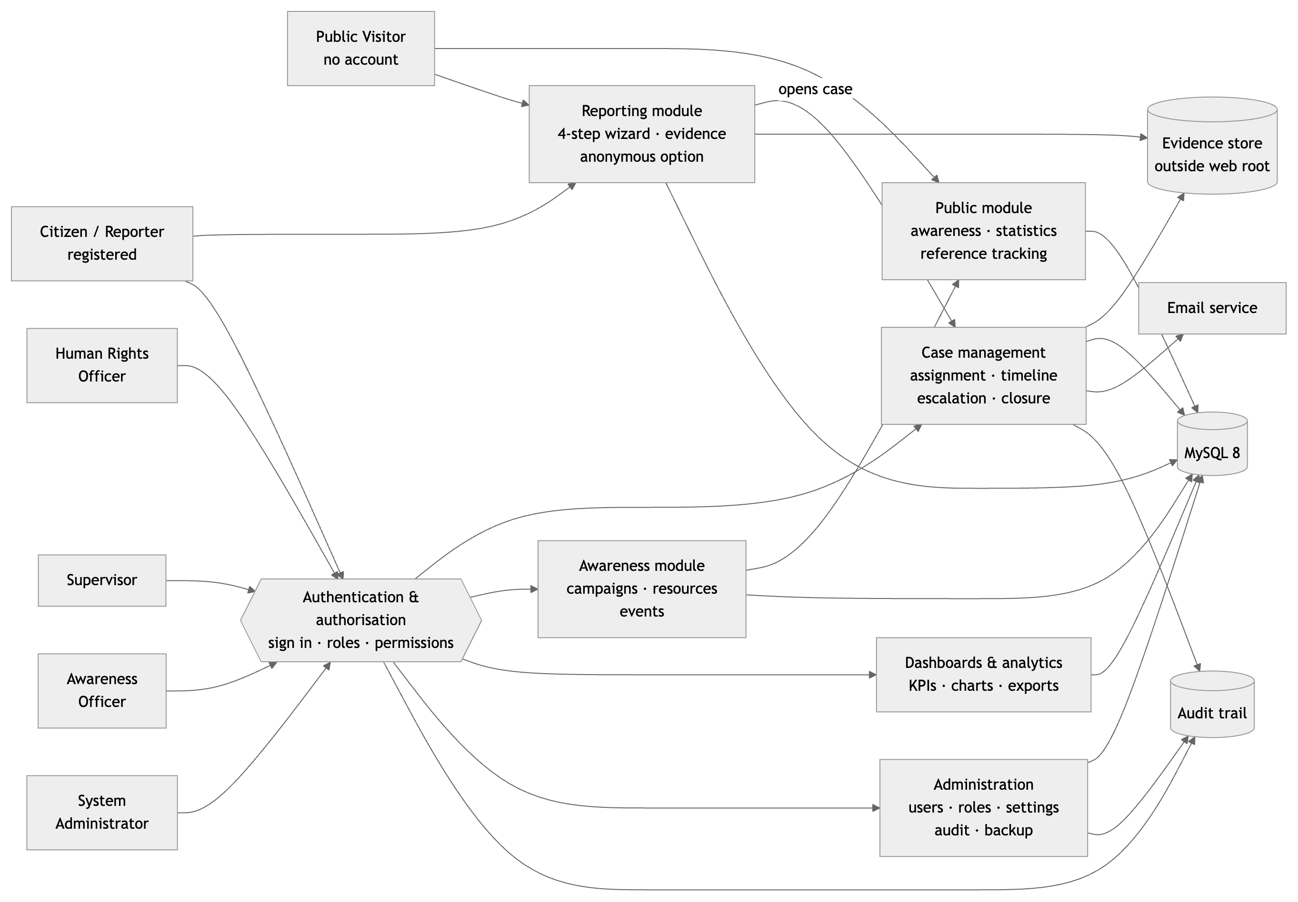

What each actor may do
Actor | Authentication | Capabilities
Public Visitor | none required | Browse campaigns, news, resources and events; read aggregate statistics; file a report anonymously; track any report by its reference number
Citizen / Reporter | account, email-verified | Everything a visitor can, plus a history of their own reports, a per-report timeline of shared updates, printable acknowledgement receipts, profile management and notifications
Human Rights Officer | account + officer role | Investigate the cases assigned to them: case notes, evidence and findings upload, interview scheduling, information requests, investigative status changes. Cannot open another officer's case, and cannot conclude their own
Supervisor | account + supervisor role | Assign and reassign cases with live workload figures, escalate, approve, resolve, close or reject; departmental statistics and officer performance reporting
Awareness Officer | account + awareness role | Create and publish campaigns, news, articles, success stories, newsletters, educational resources and community events; engagement analytics
System Administrator | account + admin role | All of the above, plus user and role management, the permission matrix, report categories, system settings, the full audit log and database backup

Three things this diagram is meant to make obvious.
A public visitor reaches the reporting module without passing through authentication — that is deliberate, because requiring an account to report a violation excludes exactly the people most likely to need the service. Everything else protected passes through the authentication and authorisation layer first. And a report never sits loose: submitting one opens a case file in the same database transaction, so nothing can be received and then forgotten.

1.2 Technical architecture
The same system by tier, showing where each responsibility physically lives.
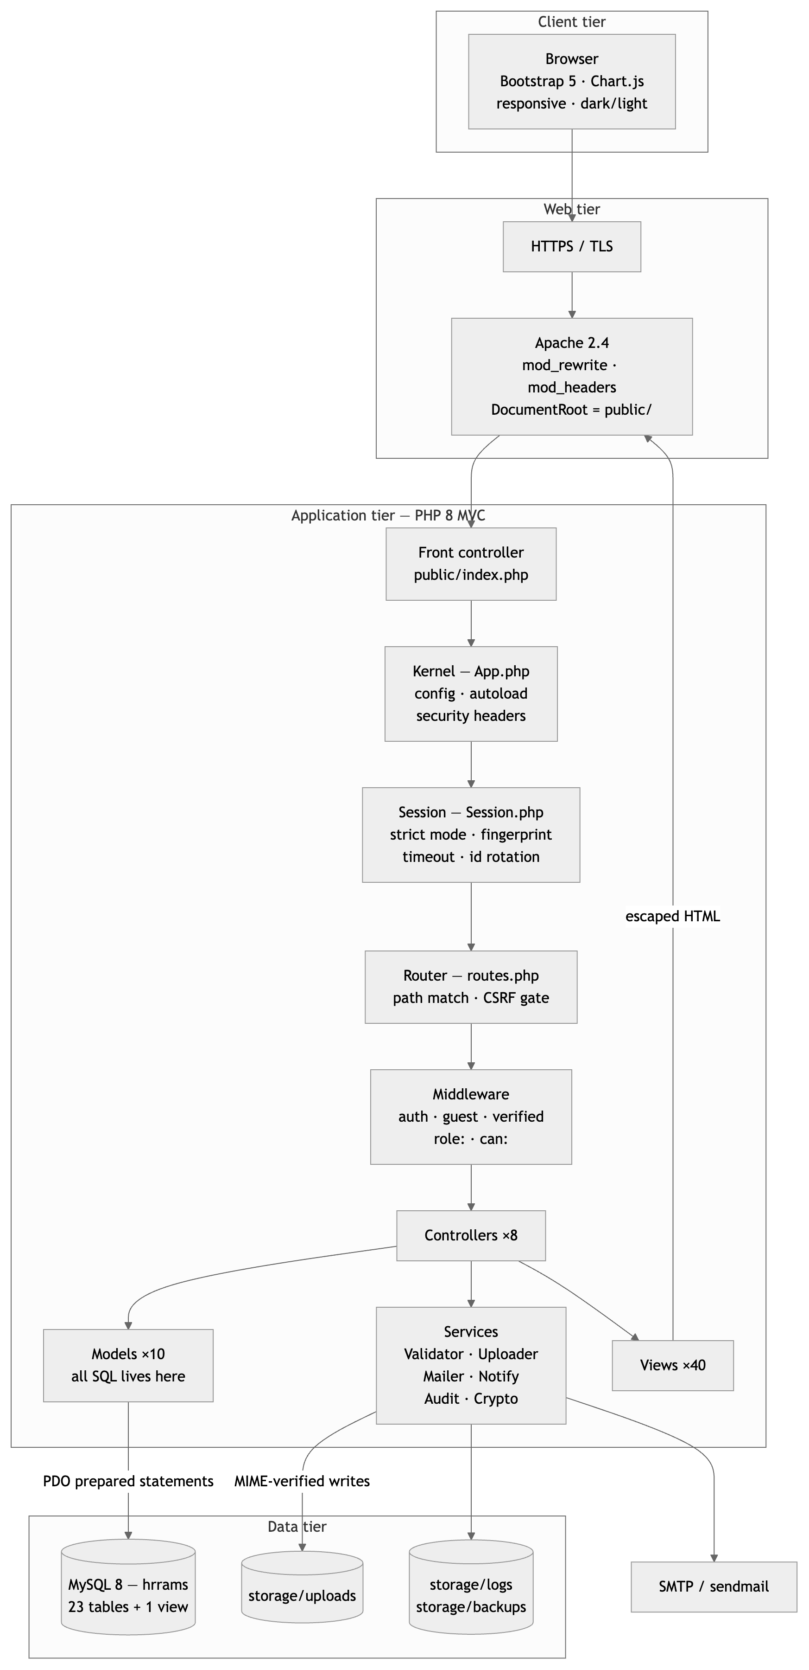
Only `public/` is web-exposed. Application code, configuration, evidence files, logs and backups all sit above the document root, each with its own .htaccess denying HTTP access. Two consequences matter: a server misconfiguration cannot leak source or credentials, and an uploaded file can never be executed because it is never inside a served directory.
One entry point. Every request goes through public/index.php, so security headers, session hardening, CSRF verification and authorisation are structural rather than something each page has to remember.

1.3 Request lifecycle
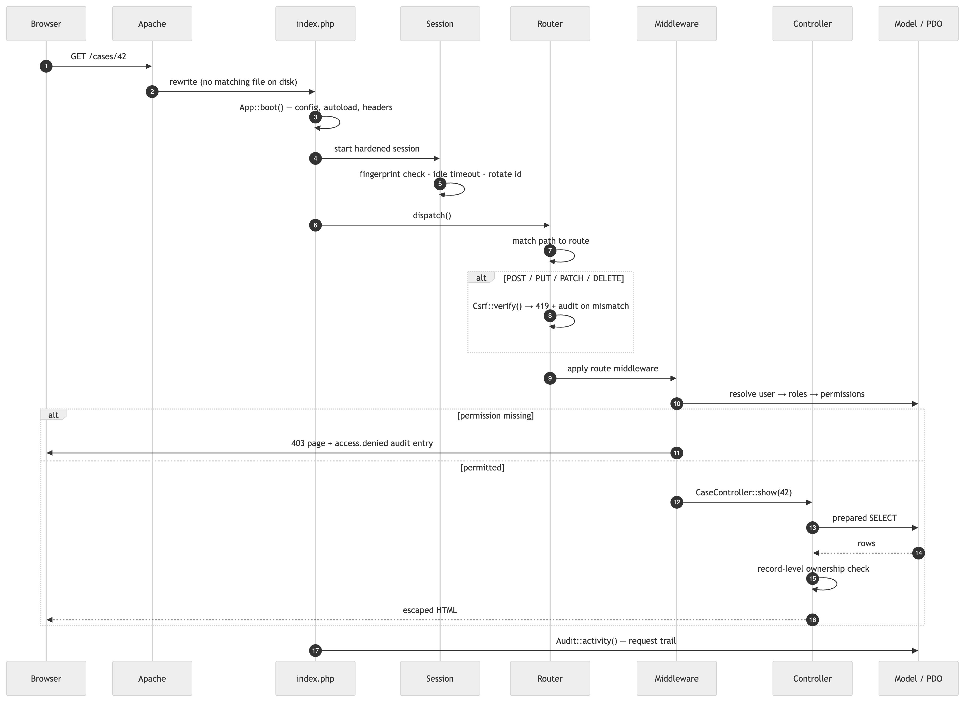
Note step ordering: CSRF is verified before middleware, and authorisation before the controller runs. A route cannot forget either, because neither is the controller's job.

2. Entity Relationship Diagram
Crow's-foot notation. ||--o{ reads "exactly one to zero-or-many".

2.1 Core entities
The entities named in the deliverable — users, roles, reports, cases, categories, case activities and audit logs — with their attributes.
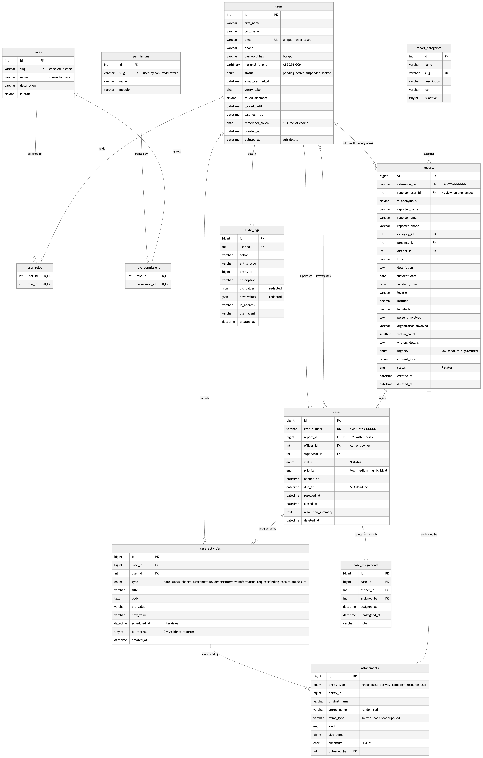

2.2 The remaining tables
The eleven entities above are the operational core. The full schema is 23 tables; the rest fall into four groups:
Group | Tables | Role
Authentication support | password_resets, login_history | Hashed single-use reset tokens; a record of every sign-in attempt
Geography | provinces, districts | Reference data for the cascading location selects. districts is a child of provinces, unique per (province_id, name)
Awareness content | awareness_campaigns, educational_resources, events, comments | Published campaigns, news, stories and newsletters; downloadable resources; community events; moderated comments
Operations | notifications, activity_logs, settings | In-app messages; a per-request trail; runtime configuration as typed key/value

Plus the reporting view `v_case_overview`, which encapsulates the five-table case join (case → report → category → province → officer) and computes age_days, so ad-hoc reporting does not restate that join.
A single diagram of all 23 tables is legible only at poster size — rendered at page width the relationship labels collapse into noise. The complete ER model, split so it stays readable, is in **ERD.md; the column-level reference is in DATABASE.md**.

2.3 Design decisions worth defending
Decision | Reasoning
reports → cases is 1:1, enforced by a unique key on cases.report_id | Guarantees every complaint has exactly one case file. Both rows are created in one transaction, so a report can never exist unhandled.
reports.reporter_user_id is nullable | Anonymous reports have no owner by design. ON DELETE SET NULL means deleting an account never destroys the complaint.
cases.officer_id is nullable, ON DELETE SET NULL | A case exists before it is assigned, and closed cases stay readable after staff leave.
case_assignments keeps history rather than being overwritten | Reassignment stamps unassigned_at and inserts a new row, preserving the chain of custody.
case_activities is append-only | The timeline is the case file. is_internal = 0 marks the entries a complainant may see.
attachments is polymorphic on (entity_type, entity_id) | One upload pipeline and one authorisation check serve reports, case findings, campaign covers and resources.
Roles ↔ permissions is many-to-many | A user may hold several roles; effective permissions are the union, resolved per request.
Soft delete (deleted_at) on business tables | Investigative and audit history must outlive an account. Audit/history tables are append-only and deliberately have no deleted_at.
Sensitive identifiers in `VARBINARY`, AES-256-GCM | Authenticated encryption, so tampering is detected rather than silently accepted.

Normalised to third normal form. Every foreign key is indexed, plus the columns actually filtered and sorted on: status, category_id, province_id, urgency, created_at, officer_id, deleted_at.
Full column-by-column reference: DATABASE.md.

3. Wireframes
Five screens, as specified. Layouts are annotated with responsive behaviour and the permission that controls each region. Breakpoints follow Bootstrap: sm 576, md 768, lg 992, xl 1200.

3.1 Public awareness page
app/Views/awareness/list.php — serves Campaigns, News and Success stories.
┌──────────────────────────────────────────────────────────────────────────────┐
│ [◆ HRRAMS] Campaigns Resources News Events Statistics Track [Report ▸] [~] │
├──────────────────────────────────────────────────────────────────────────────┤
│ ┌──────────────────────────────────────────────────────────────────────────┐ │
│ │ ░░░ full-bleed photograph, bottom-up scrim for caption contrast ░░░ │ │
│ │ │ │
│ │ ◦ AWARENESS │ │
│ │ Awareness campaigns │ │
│ │ Community programmes promoting knowledge of human rights across all │ │
│ │ ten provinces. │ │
│ └──────────────────────────────────────────────────────────────────────────┘ │
│ │
│ ┌───────────────────┐ ┌───────────────────┐ ┌───────────────────┐ │
│ │ [Campaign] 14 Aug │ │ [Campaign] 14 Aug │ │ [News] 12 Aug │ │
│ │ │ │ │ │ │ │
│ │ Know Your Rights: │ │ Every Child Has │ │ Commission Opens │ │
│ │ 16 Days of │ │ a Right to School │ │ Three New │ │
│ │ Activism │ │ │ │ Provincial Desks │ │
│ │ │ │ │ │ │ │
│ │ A nationwide │ │ Community │ │ Reporting desks │ │
│ │ campaign against │ │ outreach on the │ │ are now open in │ │
│ │ gender-based │ │ right to free │ │ Muchinga, North- │ │
│ │ violence… │ │ basic education… │ │ Western, Western │ │
│ │ │ │ │ │ │ │
│ │ Read more → │ │ Read more → │ │ Read more → │ │
│ │ * 25 Nov │ │ * 01 Mar │ │ │ │
│ └───────────────────┘ └───────────────────┘ └───────────────────┘ │
│ ↑ lifts 3px on hover, whole card is the link │
│ │
│ … 3 per row on lg, 2 on md, 1 on sm │
├──────────────────────────────────────────────────────────────────────────────┤
│ Has your right been violated? [ Report now ] │
│ You can file a report in a few minutes, anonymously if you prefer. │
├──────────────────────────────────────────────────────────────────────────────┤
│ FOOTER — brand · hotline · Report · Learn · About · Account │
└──────────────────────────────────────────────────────────────────────────────┘
Empty state. When nothing is published the grid is replaced by a single card: an icon, "Nothing has been published here yet", and "Please check back soon" — never a blank page.
Detail view (awareness/show.php) adds a type badge, publication date, author, campaign date range, view count, the body, a "Report now" call to action, and three related items.
Responsive. Banner height clamps between 180 px and 300 px. Card grid steps 3 → 2 → 1. Navbar collapses to a hamburger below lg, with "Report a violation" staying visible because it is the page's real purpose.

3.2 Login page
app/Views/auth/login.php, layout app/Views/layouts/auth.php.
┌───────────────────────────────────┬──────────────────────────────────────────┐
│ ░░ photograph under brand wash ░░ │ ← Back to site [~] │
│ │ │
│ [◆] Human Rights Commission │ Welcome back │
│ │ Sign in to manage reports, cases and │
│ Every right deserves │ campaigns. │
│ a voice. │ │
│ │ Email address * │
│ A secure platform for │ ┌─────────────────────────────────────┐ │
│ reporting violations, │ │ @ you@example.org │ │
│ tracking investigations │ └─────────────────────────────────────┘ │
│ and building awareness │ │
│ across every province. │ Password * Forgot password? │
│ │ ┌──────────────────────────────┬──────┐ │
│ # Encrypted submissions │ │ # •••••••••• │ o │ │
│ o Anonymous supported │ └──────────────────────────────┴──────┘ │
│ t Transparent tracking │ │
│ & Awareness programmes │ ┌── after 2 failed attempts ──────────┐ │
│ │ │ Security question: What is 4 + 7? │ │
│ [ Report without an account ] │ │ [____] │ │
│ │ └─────────────────────────────────────┘ │
│ │ │
│ │ ☐ Keep me signed in on this device │
│ │ [ Sign in ] │
│ │ No account yet? Create one │
│ │ ──────────────────────────────────── │
│ │ o You do not need an account to report │
│ │ Anyone can file a report, │
│ │ anonymously if they prefer. │
│ │ [ Report a violation ] │
└───────────────────────────────────┴──────────────────────────────────────────┘
Deliberate choices. The CAPTCHA appears only after two failed attempts in the session, so ordinary users never meet it. It is an arithmetic question rather than an image — accessible, and no third-party service. The panel at the bottom exists because the most common reason someone lands here is a mistaken belief that they need an account to report; it redirects them in one click.
Responsive. The branding panel is display:none below lg; the form centres with a 27 rem cap. The same layout serves register, forgot-password and reset.

3.3 Human-rights reporting form
app/Views/report/create.php — a four-step wizard, submitted as a single POST.
┌──────────────────────────────────────────────────────────────────────────────┐
│ ◦ CONFIDENTIAL SUBMISSION │
│ Report a human rights violation │
│ Take your time. Only the category, a title, a description and your │
│ consent are required — everything else helps but can be left blank. │
├──────────────────────────────────────────────────────────────────────────────┤
│ ━━━━━━━━━━━━━━━ ────────────── ────────────── ────────────── │
│ 1. Who is 2. The 3. Evidence 4. Review & │
│ reporting incident submit │
├──────────────────────────────────────────────────────────────────────────────┤
│ ▸ STEP 1 — WHO IS REPORTING │
│ ┌────────────────────────────────────────────────────────────────────────┐ │
│ │ (●──) Report anonymously │ │
│ │ With this on, no name, phone, email or address is stored with your │ │
│ │ report. You will still get a reference number to track it — write it │ │
│ │ down, because we will have no way to contact you or recover it. │ │
│ └────────────────────────────────────────────────────────────────────────┘ │
│ Full name * │ Phone number ← whole block hides when │
│ Email address │ Nationality anonymous is switched on, │
│ Address and its required flags drop │
├──────────────────────────────────────────────────────────────────────────────┤
│ ▸ STEP 2 — THE INCIDENT │
│ Short title * ·························· │ Urgency * [Medium ▾] │
│ Category of violation * [ ▾ 12 categories ] │
│ What happened? * ┌───────────────────────────────────────────────────────┐ │
│ │ (7 rows, minimum 30 characters) │ │
│ └───────────────────────────────────────────────────────┘ │
│ Date [ ] │ Time [ ] │ Number of victims [ 1 ] │
│ Province [ ▾ ] ──AJAX──▸ District [ ▾ ] │
│ Specific location ······································· │
│ ┌── GPS coordinates (optional) ─────────── [ Use my current location ] ───┐ │
│ │ Latitude ············ Longitude ············ │ │
│ │ Only shared with the officer handling your case. │ │
│ └────────────────────────────────────────────────────────────────────────┘ │
│ Persons involved │ Organisation involved │ Witness details │
├──────────────────────────────────────────────────────────────────────────────┤
│ ▸ STEP 3 — EVIDENCE │
│ ┌╌╌╌╌╌╌╌╌╌╌╌╌╌╌╌╌╌╌╌╌╌╌╌╌╌╌╌╌╌╌╌╌╌╌╌╌╌╌╌╌╌╌╌╌╌╌╌╌╌╌╌╌╌╌╌╌╌╌╌╌╌╌╌╌╌╌╌╌╌╌┐ │
│ ╎ ^ upload ╎ │
│ ╎ Drop files here, or click to browse ╎ │
│ ╎ JPG PNG WEBP GIF · MP4 MOV · MP3 WAV · PDF DOC DOCX ╎ │
│ ╎ up to 10 files, 20 MB each ╎ │
│ └╌╌╌╌╌╌╌╌╌╌╌╌╌╌╌╌╌╌╌╌╌╌╌╌╌╌╌╌╌╌╌╌╌╌╌╌╌╌╌╌╌╌╌╌╌╌╌╌╌╌╌╌╌╌╌╌╌╌╌╌╌╌╌╌╌╌╌╌╌╌┘ │
│ (+ clinic-report.pdf 1.2 MB) (+ photo.jpg 0.8 MB) Clear │
│ ! Never put yourself at risk to gather evidence. A report without any │
│ attachments is still investigated. │
├──────────────────────────────────────────────────────────────────────────────┤
│ ▸ STEP 4 — REVIEW & SUBMIT │
│ ┌────────────────────────────────────────────────────────────────────────┐ │
│ │ Reported by Category Urgency Incident date │ │
│ │ Joseph Tembo Labour Rights High 2026-07-14 │ │
│ │ Province District Location Evidence files │ │
│ │ Southern Choma Choma market 2 attached │ │
│ └────────────────────────────────────────────────────────────────────────┘ │
│ ☐ Consent declaration * — I confirm this information is true to the best │
│ of my knowledge, and consent to it being processed and, where necessary, │
│ shared with the officers and authorities required to investigate it. │
│ i On submission you receive a reference such as HR-2026-000123. │
├──────────────────────────────────────────────────────────────────────────────┤
│ [ ← Back ] Cancel [ Continue → ] / [ Submit ] │
└──────────────────────────────────────────────────────────────────────────────┘
Behaviour. Each step is validated with the HTML5 constraint API before the user can advance, so nobody is told about an error on a step they cannot see. Every rule is then re-checked server-side — the client validation is convenience, not security. The review panel is rebuilt from live field values on entry to step 4. The whole wizard is one POST, so there is no partial server-side state to lose.

3.4 Officer dashboard
app/Views/dashboard/index.php, layout app/Views/layouts/app.php.
┌───────────────┬──────────────────────────────────────────────────────────────┐
│ [◆ HRRAMS] │ ⌂ / Dashboard [? search…] [!³] [~] [DP Daniel Phiri ▾] │
│ ├──────────────────────────────────────────────────────────────┤
│ OVERVIEW │ Good morning, Daniel │
│ ▸ Dashboard │ Friday, 14 August 2026 · Officer dashboard │
│ │ │
│ CASE WORK │ ┌──────┐┌──────┐┌──────┐┌──────┐┌──────┐ │
│ ▸ My cases │ │ 14 ││ 3 ││ 1 ││ 38 ││ 21 d │ each tile links to │
│ ▸ Overdue │ │Active││Over- ││Escal-││Conc- ││ Avg. │ a filtered case │
│ │ │cases ││ due ││ated ││luded ││resol.│ list │
│ MY ACCOUNT │ └──────┘└──────┘└──────┘└──────┘└──────┘ │
│ ▸ My reports │ ┌─────────────────────────────────┬────────────────────────┐ │
│ ▸ My profile │ │ REPORT VOLUME, LAST 12 MONTHS │ ! NEEDS ATTENTION NOW │ │
│ │ │ ╱╲ ╱╲ │ • Unlawful detention │ │
│ [+ New report]│ │ ╱╲╱ ╲╱╲╱ ╲╱╲ │ CASE-2026-00031 41 d │ │
│ │ │ ╱ ╲ │ • Unpaid wages │ │
│ │ └─────────────────────────────────┤ CASE-2026-00028 36 d │ │
│ │ ┌───────────────┬───────────────┐ ├────────────────────────┤ │
│ │ │ BY CATEGORY │ BY STATUS │ │ * UPCOMING INTERVIEWS │ │
│ │ │ ▄▄▄▄▄▄▄▄ │ ◕ │ │ [14 AUG] Complainant │ │
│ │ │ ▄▄▄▄▄ │ doughnut │ │ 09:00 CASE-2026-00031 │ │
│ │ │ ▄▄▄ │ │ │ [16 AUG] Site witness │ │
│ │ └───────────────┴───────────────┘ ├────────────────────────┤ │
│ │ ┌─────────────────────────────────┤ ! NOTIFICATIONS │ │
│ │ │ MY OPEN CASES │ • New case assigned │ │
│ │ │ Case │Subject│Pri│Status│Age │ │ • Info received │ │
│ │ │ ─────┼───────┼───┼──────┼──── │ ├────────────────────────┤ │
│ │ │ …8 rows, row click → case… │ │ LATEST REPORTS │ │
│ │ └─────────────────────────────────┴────────────────────────┘ │
└───────────────┴──────────────────────────────────────────────────────────────┘
Role-shaped. An officer sees only their own workload — the same view for a supervisor adds an "Unassigned" tile and a "Team workload" table, because case.assign and dashboard.department are present. The sidebar is built from the same can() checks that gate the routes, so the navigation never offers an action the user would be refused.
"Needs attention now" is placed first on the right because it is the one panel that should change what the officer does next.
Responsive. Sidebar becomes an off-canvas drawer below lg (hamburger, backdrop, Esc to close). KPI tiles wrap 5 → 2 per row. The right column stacks under the charts below xl. Charts load over AJAX with shimmer skeletons, so a slow aggregation never blocks the page.

3.5 Case management page
app/Views/cases/show.php — the main working surface.
┌──────────────────────────────────────────────────────────────────────────────┐
│ ← Back to cases │
│ Unlawful detention at Kanyama police post [High priority] [ASSIGNED] │
│ Case CASE-2026-00031 · Report HR-2026-000117 · Opened 03 Jul 2026 │
├──────────────────────────────────────────────────────────────────────────────┤
│ ! This case passed its service deadline on 10 Jul 2026. Record progress or │
│ escalate it. │
├─────────────────────────────────────────────┬────────────────────────────────┤
│ THE COMPLAINT │ ASSIGNMENT │
│ Two family members were held for four days │ (DP) Daniel Phiri │
│ without charge and without access to a │ officer@hrrams.test │
│ lawyer. No warrant was produced. │ Supervisor Grace Mulenga │
│ ─────────────────────────────────────────── │ Due by 10 Jul 2026 │
│ Category │ Incident date & time │ ────────────────────────────── │
│ Arbitrary Arrest│ 02 Jul 2026 · 21:30 │ Assign to [ ▾ ] (3 open) │
│ Location │ GPS coordinates │ Instruction ················ │
│ Kanyama post │ -15.4310, 28.2650 → map │ [ Assign case ] │
│ Victims 2 │ Organisation ZP Kanyama │ ↑ can:case.assign only │
│ Persons involved / Witness details ├────────────────────────────────┤
├─────────────────────────────────────────────┤ COMPLAINANT │
│ RECORD AN ACTION │ Name Joseph Tembo │
│ ┌────────┬────────┬─────────┬──────┬──────┐ │ Email joseph@example.org │
│ │Case │Upload │Schedule │Req. │Change│ │ Phone +260 97 000 0005 │
│ │note │findings│interview│info │status│ │ # Every view is audit-logged. │
│ └────────┴────────┴─────────┴──────┴──────┘ │ (or: "Filed anonymously — │
│ ↑ each tab shown only if the permission │ cannot be contacted") │
│ is held; officer sees 5, supervisor 3 ├────────────────────────────────┤
│ ┌─────────────────────────────────────────┐ │ EVIDENCE ③ │
│ │ Heading ······························· │ │ D clinic-report.pdf 1.2 MB │
│ │ Note * ┌────────────────────────────┐ │ │ I photo.jpg 0.8 MB │
│ │ │ │ │ │ M statement.mp3 3.1 MB │
│ │ └────────────────────────────┘ │ │ ↑ streamed only to │
│ │ ☐ Visible to the complainant [+ Add] │ │ authorised users │
│ └─────────────────────────────────────────┘ ├────────────────────────────────┤
├─────────────────────────────────────────────┤ RESOLUTION │
│ CONCLUDE THE CASE [⌄] │ (shown once concluded) │
│ Outcome [Resolved ▾] ← can:case.close │ │
│ Resolution summary * (min 20 chars, │ │
│ shared with the complainant) │ │
├─────────────────────────────────────────────┴────────────────────────────────┤
│ INVESTIGATION TIMELINE 6 entries │
│ ●─ Status changed to Investigating Daniel Phiri · 05 Jul 10:12 │
│ │ [Assigned] → [Investigating] │
│ ●─ Interview scheduled [Shared] Daniel Phiri · 04 Jul 16:40 │
│ │ * Scheduled for 14 Aug 2026, 09:00 │
│ ●─ Evidence uploaded: medical report Daniel Phiri · 04 Jul 11:20 │
│ ●─ Case assigned Grace Mulenga · 03 Jul 09:05 │
│ ↑ dot colour encodes entry type │
└──────────────────────────────────────────────────────────────────────────────┘
Separation of duties is visible in the UI. An officer gets notes, findings, interviews, information requests and the investigative status changes. Only a holder of case.close — supervisor or administrator — sees resolve/close/reject and the "Conclude the case" panel. An officer therefore cannot conclude their own investigation, which is what makes the supervisory review meaningful.
The complainant panel is the sensitive one. It shows contact details only to the assigned officer or a case-wide permission holder, states plainly that access is logged, and for an anonymous report says so instead of showing empty fields.
Wireframes for the remaining screens — case list, all-reports browser, admin dashboard, user management, roles matrix, tracking, receipts — are in WIREFRAMES.md, along with the design-token and accessibility reference.

4. Authentication System
Implemented in app/Core/Auth.php, app/Core/Session.php, app/Core/Middleware.php, app/Core/Csrf.php and app/Controllers/AuthController.php.

4.1 Registration
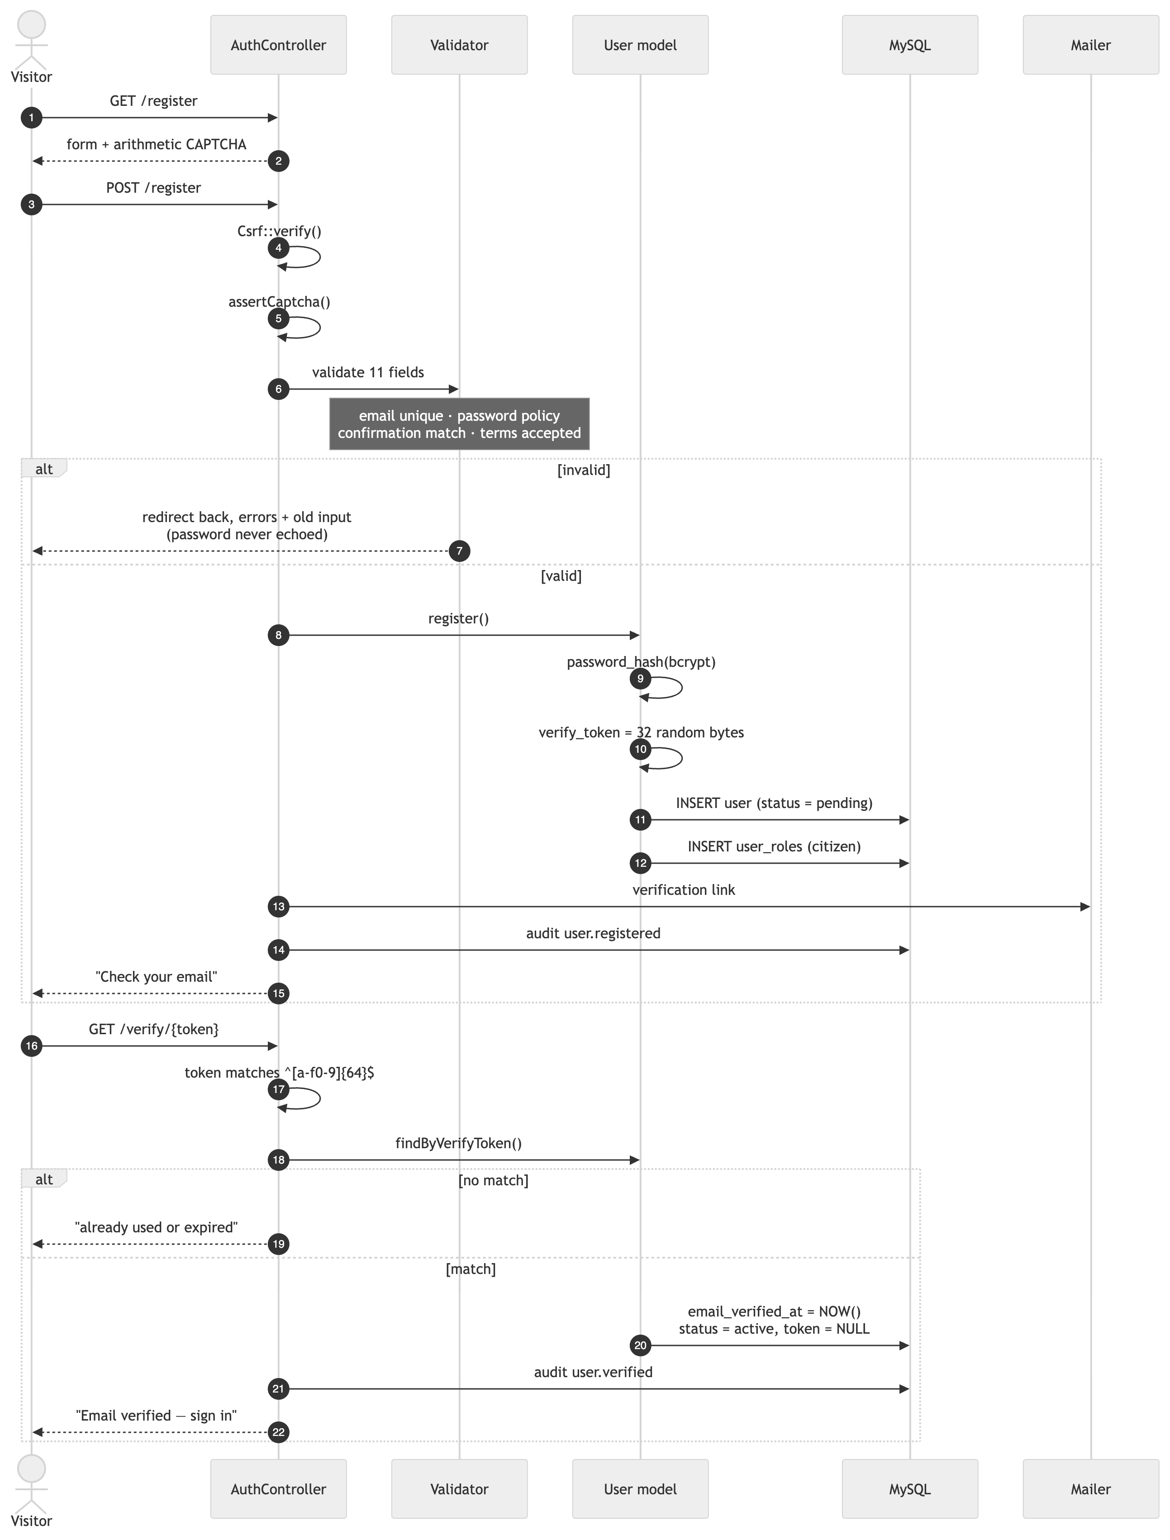
Password policy — enforced server-side by the password rule in Validator.php: minimum 10 characters (configurable) plus an uppercase letter, a lowercase letter, a digit and a symbol. The client-side strength meter is guidance only.
New accounts get the `citizen` role. Staff accounts are created by an administrator, who picks the roles explicitly.

4.2 Login
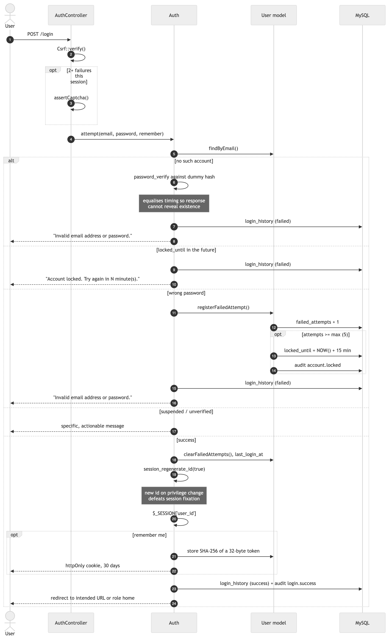
Uniform failure messages. A wrong password and a non-existent account return the identical string, and the non-existent branch still runs password_verify against a dummy hash so the timing matches. Without that, response time alone enumerates valid accounts.
Role-appropriate landing page — Auth::homeRoute(): admin → /admin/dashboard, supervisor and officer → /dashboard, awareness officer → /awareness/manage, citizen → /my/reports. An intended URL captured before the redirect to login takes precedence.

4.3 Role-based access control
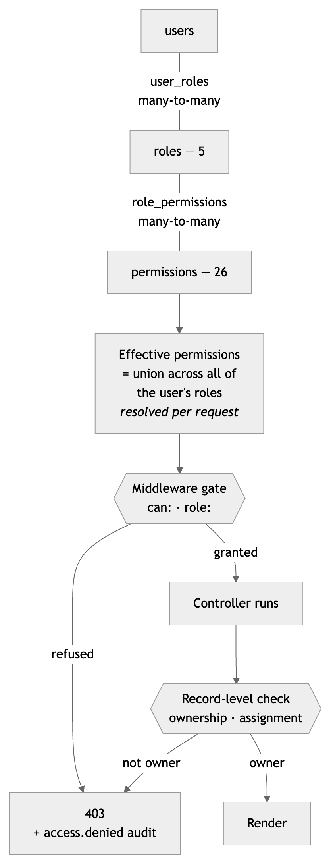

The five roles
Role | Slug | Purpose
Registered Citizen / Reporter | citizen | Submits and tracks their own reports
Human Rights Officer | officer | Investigates assigned cases
Supervisor | supervisor | Assigns, approves, escalates and closes
Awareness Officer | awareness | Manages campaigns, resources and events
System Administrator | admin | Full system access

Permission matrix
● granted in the seed. Editable at runtime in Administration → Roles.
Permission | Citizen | Officer | Supervisor | Awareness | Admin
report.create | ● |  |  |  | ●
report.view_own | ● |  |  |  | ●
report.view_any |  | ● | ● |  | ●
report.delete |  |  |  |  | ●
case.view_assigned |  | ● | ● |  | ●
case.view_any |  |  | ● |  | ●
case.update |  | ● | ● |  | ●
case.note |  | ● | ● |  | ●
case.evidence |  | ● |  |  | ●
case.interview |  | ● |  |  | ●
case.assign |  |  | ● |  | ●
case.approve |  |  | ● |  | ●
case.escalate |  |  | ● |  | ●
case.close |  |  | ● |  | ●
awareness.manage |  |  |  | ● | ●
awareness.analytics |  |  |  | ● | ●
event.manage |  |  |  | ● | ●
dashboard.department |  |  | ● |  | ●
dashboard.admin |  |  |  |  | ●
user.manage |  |  |  |  | ●
role.manage |  |  |  |  | ●
category.manage |  |  |  |  | ●
settings.manage |  |  |  |  | ●
audit.view |  |  |  |  | ●
backup.manage |  |  |  |  | ●
report.export |  | ● | ● | ● | ●

Two permissions carry more weight than their names suggest. `case.view_any` removes the ownership restriction, so its holder can open every case in the organisation including complainant contact details — grant it sparingly. `case.close` allows concluding a case; keeping it away from officers is what makes supervisory review real rather than nominal.

How enforcement works
Routes declare their requirement in config/routes.php:
$r->get('/cases', ['CaseController', 'index'], ['auth']);
$r->post('/cases/{id}/assign', ['CaseController', 'assign'], ['can:case.assign']);
$r->get('/admin/users', ['AdminController', 'users'], ['can:user.manage']);
$r->get('/dashboard', ['DashboardController','index'],
['role:officer|supervisor|admin']);
Middleware | Effect
auth | Must be signed in; stores the intended URL and redirects to login
guest | Signed-in users are bounced to their role home
verified | Email must be confirmed
`role:a\ | b`
can:slug | Must hold the permission

Permissions are resolved per request in Auth::permissions(), not cached in the session — so a revoked role takes effect on the user's very next request without them signing out.
Record-level checks layer on top, because a permission alone is not authorisation:
Check | Location | Rule
Case ownership | CaseController::authorisedCase() | Without case.view_any, cases.officer_id must be the current user
Report ownership | ReportController::showMine() | reports.reporter_user_id must be the current user
Evidence access | CaseController::mayViewAttachment() | Case-wide permission, or the reporter who filed it, or the assigned officer
Self-protection | AdminController | An administrator cannot delete or suspend their own account, nor strip their own admin role

Every refusal writes an access.denied audit entry naming the permission that was missing.
The same can() helper drives menu and button visibility, so the interface never advertises a forbidden action — but the gate, not the hidden button, is the control.

4.4 Password reset
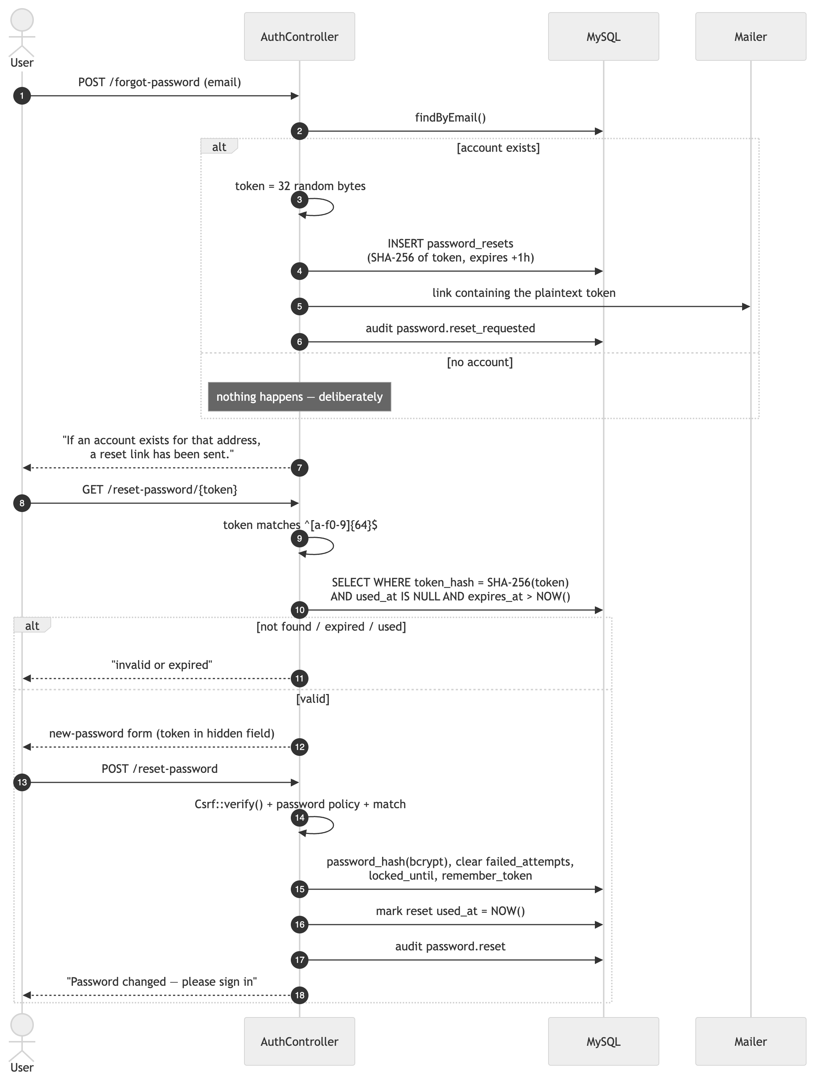
Four properties worth naming:
- The token is stored only as a SHA-256 hash. A database leak cannot be replayed to seize accounts — the plaintext exists solely in the emailed link.
- One hour, one use. expires_at and used_at are both checked in the lookup.
- The response never reveals whether the address is registered. Same message either way.
- Resetting revokes the remember-me token and clears any lockout, so a legitimate owner locked out by an attacker's failed attempts regains access.
Changing a password while signed in (/my/password) requires the current password; a failure is audited as password.change_failed.

4.5 Secure session management
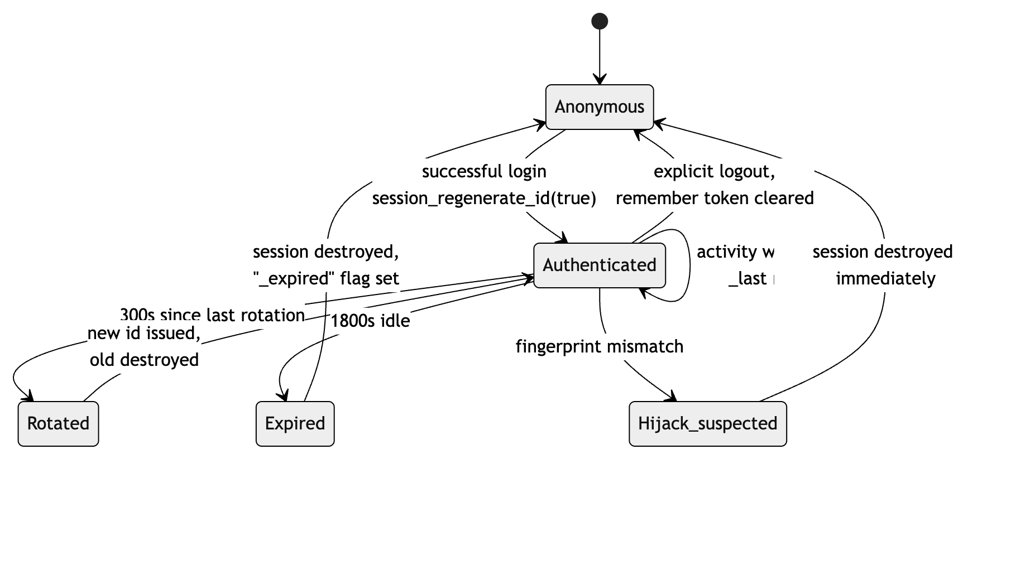
Configured in Session::start():
Control | Setting | Why
Strict mode | session.use_strict_mode = 1 | The server refuses a session id it never issued, defeating fixation
Cookies only | session.use_only_cookies = 1 | No session id in URLs, so it cannot leak via Referer or logs
httpOnly | session.cookie_httponly = 1 | JavaScript cannot read the cookie, so XSS cannot steal the session
SameSite | Lax | Blocks the cookie on cross-site POSTs
Secure | on under HTTPS | Never transmitted in clear
Entropy | sid_length = 48, 5 bits/char | Not guessable
Custom name | HRRAMSSESSID | Does not advertise the platform
Fingerprint | SHA-256 of user agent + language | A mismatch destroys the session
Idle timeout | 1800 s, configurable | A walked-away-from terminal does not stay authenticated
Rotation | every 300 s, old id deleted | Shrinks the window in which a stolen id is useful
Regeneration | on every successful login | The id a user held before authenticating never carries privilege

The browser is warned two minutes before expiry, and after an expiry the next page explains what happened rather than silently showing a login form.
CSRF. A 32-byte per-session token is required on every POST, PUT, PATCH and DELETE. Router::dispatch() calls Csrf::verify() before middleware or controller, so a route cannot forget it. Tokens are compared with hash_equals(). A failure returns 419, writes a csrf.failed audit entry, and does not process the request.
Remember-me. The cookie carries userId:token; only the SHA-256 of the token is stored. It is httpOnly, SameSite=Lax, secure under HTTPS, and 30 days. It is cleared on logout and on password change.

4.6 What gets logged
Table | Contents
login_history | Every attempt — email, IP, user agent, success flag. Keeps the email even when no user matched, so attacks on non-existent accounts stay visible.
audit_logs | Security-relevant actions with before/after values, actor, IP, user agent
activity_logs | One row per request — route, method, actor, IP

Authentication events recorded: login.success, login.failed, logout, account.locked, user.registered, user.verified, password.changed, password.reset, password.reset_requested, password.change_failed, user.roles_changed, user.status_changed, access.denied, csrf.failed.
Passwords, hashes, tokens, 2FA secrets and national IDs are replaced with [redacted] before an audit row is written. Audit writes are wrapped in try/catch, so logging can never break the request it is recording — a failure goes to storage/logs/audit.log instead.
Users can review their own last ten sign-in attempts from My profile, which is how an ordinary user would notice an unfamiliar successful login.

5. Verification evidence
Exercised against a live MySQL 8 database through both the PHP dev server and Apache under MAMP.
Area | Test | Result
Registration | Full form submit, citizen role assigned, verification token issued | Pass
Login | Correct credentials → role-appropriate dashboard | Pass
Login | Wrong password and unknown account return the identical message | Pass
Lockout | 5 failed attempts sets locked_until, audits account.locked | Pass
CAPTCHA | Appears from the third attempt in a session | Pass
Password reset | Link issued, hashed in DB, single-use, one-hour expiry honoured | Pass
Session | Id regenerates on login; rotates every 300 s; idle expiry destroys it | Pass
CSRF | Forged token → 419 + csrf.failed audit entry | Pass
RBAC | Supervisor refused /admin/users (403) | Pass
RBAC | Officer refused /officers, /admin/roles, /admin/audit, case.assign | Pass
Record-level | Officer refused a case not assigned to them (403 + audit) | Pass
Record-level | Citizen refused another reporter's report (403) | Pass
Evidence | Assigned officer can stream a file; citizen refused the same file (403) | Pass
Upload | Shell script sent as application/pdf rejected by MIME sniffing | Pass
Self-protection | Administrator cannot delete own account or drop own admin role | Pass
Reporting | Report → auto-opened case → receipt → public tracking | Pass
SLA | Critical urgency = 3-day deadline, high = 7 days | Pass
Case lifecycle | Assign → note → status → escalate → conclude, all timeline-logged | Pass
Notifications | Assignment and status changes reach the right roles and the reporter | Pass
Directory exposure | config/, storage/, app/, database/ unreachable over HTTP | Pass

Four defects were found and fixed during this testing: a namespace-alias collision in helpers.php; HIGH_PRIORITY used as a SQL alias, which is a reserved word in MySQL 8; error pages returning HTTP 200 alongside their error content; and an unvalidated district_id producing a foreign-key failure instead of a field error. Two further Apache-only defects were found when deploying behind MAMP: unguarded php_flag directives, invalid under FastCGI, and a hard-coded RewriteBase / that broke subdirectory installs.

6. Known gaps
Stated plainly so they are not mistaken for finished work.
Gap | Status | Impact
Two-factor authentication | users.twofa_secret and twofa_enabled columns exist; no TOTP flow built | Staff accounts rely on password + lockout alone
SMTP authentication | Mailer supports log and PHP mail(); the smtp config block is read but authenticated delivery is not implemented | Needs a local relay, or PHPMailer, before production email works
Rate limiting | Lockout is per-account, not per-IP | A distributed attempt across many accounts is not throttled at the application layer; add it at the web server or WAF
CSP `unsafe-inline` | Still permitted for scripts and styles | Weakens XSS defence in depth; replacing it with a per-request nonce is the highest-value hardening step available
Supervisor interview scheduling | case.interview is officer-only in the seed | A supervisor who also investigates must be granted it in Administration → Roles
Comment moderation | comments table and model exist; no public submission form | No user-facing effect today

Related documents
Document | Contents
ARCHITECTURE.md | Layer responsibilities, module map, case lifecycle, performance
ERD.md | Full ER model and relationship notes
DATABASE.md | Table-by-table reference, indexes, maintenance queries
WIREFRAMES.md | Remaining screens, design tokens, accessibility
SECURITY.md | OWASP Top 10 control mapping, hardening checklist
USER-MANUAL.md | Guidance for citizens, officers and supervisors
ADMIN-GUIDE.md | Administrator and awareness officer guidance
INSTALLATION.md | Setup and troubleshooting
DEPLOYMENT.md | Production deployment and go-live checklist

